**SCRAPPIE**

### REAL TIME PROJECT

**Bachelor of Technology (B.Tech-II year / II Semester) In**

### COMPUTER SCIENCE AND ENGINEERING

**By**

### B. SANJAY 22AG1A0505

**R.BHARATH KUMAR 22AG1A0544**

### C. UPENDRA 22AG1A0508

**N. VENKAT TEJA 22AG1A0537**

#### Under the Esteemed Guidance of Dr. V. Ravi Kumar

Assistant Professor



# Department of Computer Science and Engineering

***ACE ENGINEERING COLLEGE***

### An Autonomous Institution

(NBA ACCREDITED B.TECH COURSES: EEE, ECE, MECH, CIVIL & CSE, ACCORDED NAAC ‘A’ GRADE)

**(Affiliated to Jawaharlal Nehru Technological University, Hyderabad, Telangana)**

Ankushapur(V),Ghatkesar(M), Medchal – Malkajgiri Dist - 501 301 JULY 2024

**ACE**

**Engineering College**

**An Autonomous Institution**

**Web site:** [**www.aceec.ac.in E-**](http://www.aceec.ac.in/)**mail:** [**info@aceec.ac.in**](mailto:info@aceec.ac.in)

### DEPARTMENT OF COMPUTER SCIENCE AND ENGINEERING

**CERTIFICATE**

This is to certify that the Real Time Project work entitled **“SCRAPPIE”** is being submitted by **B. Sanjay (22AG1A0505), R. Bharath Kumar (22AG1A0544),**

**C. Upendra (22AG1A0508), N. Venkat Teja (22AG1A0537)** in partial fulfillment of Real Time Project work during the academic year 2023-24 is a record of bonafide work carried out by them under our guidance and supervision.

#### Internal Guide Head of the Department

**Mr. V. Veeresh Associate Professor Dept. of CSE**

**Dr.M.V.VIJAYASARDI**

**Professor and Head Dept. of CSE**

**Project Coordinator Dr. V. Ravi Kumar**

# ACKNOWLEDGEMENT

I would like to express my gratitude to all the people behind the screen who have helped me transform an idea into a real time application.

I would like to express my heart-felt gratitude to my parents without whom I would not have been privileged to achieve and fulfill my dreams.

A special thanks to our General Secretary, **Prof. Y. V. Gopala Krishna Murthy**, for having founded such an esteemed institution. Sincere thanks to our Joint Secretary

Mrs**. M. Padmavathi**, for support in doing project work. I am deeply grateful to our beloved Principal, **Dr. B. L. Raju** for permitting me to carry out this project.

I am profoundly grateful to **Dr. M. V. Vijaya Saradhi**, Professor and Head, Department of Computer Science and Engineering, for being an excellent guide and also a great source of inspiration to my work.

I am extremely thankful to **Dr.V.Ravi Kumar**, Associate Professor and Project Coordinator, who helped me throughout my Real-Time / Field Based Research Project.

I am very thankful to my internal guide **Mr. V. Veeresh** , Associate Professor who has beenan excellent guide and also given continuous support for the Completion of my project work.

The satisfaction and euphoria that accompany the successful completion of the task would be great, but incomplete without the mention of the people who made it possible, whose constant guidance and encouragement crown all the efforts with success. In this context, I would like to thank all the other staff members, both teaching and non-teaching, who have extended their timely help and eased my task.

### B.SANJAY(22AG1A0505) R.BHARATH KUMAR (22AG1A0544)

**C. UPENDRA (22AG1A0508) N.VENKAT TEJA (22AG1A0537)**

ACE

**Engineering College**

**An Autonomous Institution**

Ghatkesar, Medchal (Dist), Hyderabad, Telangana State – 501 301 (NBA Accredited B.Tech Courses, Accorded NAAC ‘A’ Grade)

**DEPARTMENT OF COMPUTER SCIENCE AND ENGINEERING**

### Real Time Research Projects

**INDEX**

### CONTENTS Page No

Abstract 6

Feasibility Study 7

* Technical Feasibility 7
* Financial Feasibility 7
* Product Feasibility 7

Literature Survey & Practical observation 8

1. Introduction 10
   1. Purpose 10
   2. Scope 10
   3. Real-Time usage & Applications 11
   4. Target Audience 11
2. Overall Description 12
   1. User Interfaces & Characteristics 12
   2. System Interfaces & Communication Interfaces 13
3. System Analysis 14
   1. Existing System & Draw backs 14
   2. Proposed System & Overcoming draw backs 15
   3. Team Size 16
4. Software and Hardware Requirements 17
5. Architecture Diagram / Flow Diagram / Hierarchical Chart 18

/ Pie Chart

1. Software Design 21
2. Module Description 28
3. Implementation (Pseudo Code) 29
4. Test Cases 32
5. Output Screens 33
6. Conclusions 40
7. Future enhancements 41
8. References 42

**Project Coordinator Head of the Department**

**Dr. V. Ravi Kumar Dr. M. V. Vijaya Saradhi Associate Professor HoD CSE & IoT**

# ABSTRACT

In today's world, where environmental sustainability is increasingly paramount, the effective management of scrap materials stands as a critical component in forging a path towards a greener future. Our ambitious website project endeavours to meet this urgent need by offering a seamless and efficient platform for the sale of scrap materials, while concurrently championing sustainability and responsible waste management practices.

Through the innovative framework of our platform, users are empowered to effortlessly list their scrap materials for sale, thereby connecting with potential buyers in a streamlined and efficient manner. By facilitating these connections, we aim to not only reduce waste but also foster a culture of resource reuse, thereby promoting environmental conservation on a global scale.

Central to our mission is the creation of a user experience that is not only intuitive but also profoundly impactful. With a meticulously crafted user interface and a robust backend infrastructure, our website promises a user-friendly experience that seamlessly integrates cutting- edge technology with environmental stewardship.

Moreover, our vision extends beyond mere transactional exchanges; we aspire to cultivate a vibrant community of environmentally-conscious individuals and businesses. By uniting like-minded stakeholders, we endeavour to harness collective action towards a common goal: a sustainable future for our planet.

In summary, our website project represents a bold step towards revolutionizing the management and exchange of scrap materials, underpinned by an unwavering commitment to sustainability and environmental stewardship. We invite you to join us on this transformative journey towards a greener and more sustainable future.

# FEASIBILITY STUDY

#### Technical Feasibility

* + **Frontend:** HTML, CSS, JavaScript
  + **Backend:** Node.js with MongoDB
  + **Database:** MongoDB for data storage and retrieval
  + **Software Tools:** VS Code, GitHub, APIs for geolocation and authentication
  + **Assessment:** The project is technically feasible with the selected technology stack.

#### Financial Feasibility

* + **Development Costs:** independent
  + **Deployment Costs:** Rs.10,000/month for hosting, Rs.5000/year for domain registration
  + **Maintenance Costs:** Rs.5,000/year for ongoing development, Rs.5,000/year for updates and support
  + **Assessment:** The project is financially feasible with a manageable budget.

#### Market Feasibility

* + **Target Audience:** Individuals and businesses needing to buy/sell scrap materials
  + **Market Demand:** High demand for sustainable and efficient waste management solutions
  + **Assessment:** The product meets a significant market demand.

#### Organizational Feasibility

* + **Team Requirements:** Experienced frontend and backend developers, UI/UX designers, marketing professionals
  + **Project Management:** Agile methodology for development and deployment
  + **Assessment:** The organization has the capability to support and sustain the project.

#### Legal and Ethical Feasibility

* + **Compliance:** Ensure adherence to data protection regulations (e.g., GDPR, CCPA)
  + **Ethical Considerations:** Promote sustainability and responsible waste management practices
  + **Assessment:** The project aligns with legal requirements and ethical standards.

# LITERATURE SURVEY & PRACTICAL OBSERVATION

### Literature Survey

#### Sustainable Waste Management Practices

In recent years, numerous studies have highlighted the importance of sustainable waste management practices in reducing environmental impact. According to Smith and Jones (2019), effective waste management not only reduces the burden on landfills but also conserves natural resources by promoting the recycling and reuse of materials. This principle forms the foundation of our project, aligning with the broader goals of environmental conservation and resource optimization.

#### Online Marketplaces for Waste Materials

The concept of online marketplaces for waste materials is not entirely new. Research by Chen et al. (2020) indicates that digital platforms for buying and selling scrap materials can significantly enhance the efficiency of waste management systems. These platforms facilitate the direct exchange of materials between sellers and buyers, thus minimizing the intermediaries and associated costs. Our project builds upon this framework by introducing a user-friendly interface and robust backend infrastructure.

#### User Engagement in Environmental Platforms

Engaging users in environmental platforms is critical for their success. A study by Garcia and Lee (2021) shows that platforms that offer intuitive user experiences and actively promote community involvement tend to have higher user retention rates. Our project integrates these insights by focusing on creating an impactful and engaging user experience that encourages continuous participation and community building.

#### Technological Innovations in Waste Management

Technological advancements play a crucial role in modern waste management systems. As highlighted by Patel (2022), innovations such as real-time tracking, data analytics, and AI-driven recommendations can significantly enhance the efficiency and effectiveness of waste management platforms. Our project leverages these technologies to provide a seamless and efficient experience for users, from listing scrap materials to connecting with potential buyers.

### Practical Observation

#### User Behavior and Preferences

Through practical observation and user feedback, it has been noted that users prioritize ease of use and efficiency when engaging with online platforms for scrap material exchange. This insight has guided the design of our user interface, ensuring that the process of listing materials and connecting with buyers is straightforward and hassle-free.

#### Market Demand and Supply Dynamics

Observations of market trends indicate a growing demand for platforms that facilitate the exchange of scrap materials. This is driven by increased awareness of environmental issues and a rising trend towards sustainable business practices. Our platform is designed to meet this demand by providing a reliable and efficient marketplace for scrap materials.

#### Community Engagement

Community engagement has been observed to be a critical factor in the success of environmental initiatives. Platforms that foster a sense of community and collective action tend to see higher levels of participation and impact. Our project aims to create a vibrant community of environmentally-conscious individuals and businesses, encouraging collaboration and knowledge-sharing.

#### Technological Integration

The integration of advanced technologies has been observed to enhance user satisfaction and platform efficiency. Real-time tracking of materials, AI-driven recommendations, and data analytics are some of the technologies that have been successfully implemented in similar platforms. Our project incorporates these technologies to ensure a seamless and efficient user experience.

## INTRODUCTION

### Purpose

The Scrappie project aims to revolutionize scrap material management through a comprehensive website platform. The key objectives include:

* + - **Efficiency:** Streamline the process of buying and selling scrap materials by replacing manual, offline methods with a digital platform that automates transactions and facilitates seamless exchanges.
    - **Transparency:** Enhance transparency by providing users with real-time information on available scrap materials, pricing, and transaction statuses.
    - **Promotion of Sustainability:** Promote environmental sustainability by encouraging the reuse and recycling of scrap materials, thereby reducing waste and conserving natural resources.
    - **Community Engagement:** Foster a community of environmentally-conscious individuals and businesses by providing a platform for collaboration, knowledge sharing, and collective action towards sustainability goals.
    - **User Experience:** Enhance the overall user experience by offering a user-friendly interface and intuitive functionalities that cater to the needs of both buyers and sellers of scrap materials.
    - **Compliance:** Ensure compliance with relevant regulations and guidelines governing scrap material transactions, including waste management policies and environmental regulations.

The project ultimately seeks to create a positive impact on the planet by facilitating responsible scrap material management with a firm commitment to sustainability and environmental stewardship.

### Scope

The Scrappie project involves the development and implementation of a website platform dedicated to scrap material management. Key components include:

1. **Platform Development:** Design, development, and deployment of a user-friendly platform for listing, buying, and selling scrap materials. This includes frontend development for the user interface and backend development for database management and transaction processing.
2. **Feature Set:** Offer a range of features catering to both sellers and buyers, including user registration, listing creation, advanced search and filtering options, secure transaction processing, and real-time communication functionalities.
3. **User Roles and Permissions:** Support multiple user roles, including sellers, buyers, and administrators, with specific permissions and access levels to perform relevant actions within the platform, such as creating listings, reviewing transactions, and managing user accounts.
4. **Scalability and Performance:** Ensure scalability and performance to accommodate potential growth in user traffic and transaction volume over time, involving codebase optimization, caching mechanisms, and robust hosting infrastructure.
5. **Data Security and Privacy:** Prioritize data security and privacy, implementing measures to protect user information and transaction data from unauthorized access or misuse, including encryption of sensitive data and secure authentication mechanisms.
6. **Testing and Quality Assurance:** Conduct rigorous testing and quality assurance processes throughout the development lifecycle to ensure reliability, functionality, and usability, including unit testing, integration testing, user acceptance testing, and performance testing.
7. **Documentation and Training:** Provide comprehensive documentation to support users in navigating the platform and understanding its features and functionalities, and develop training materials to onboard new users and administrators effectively.

### Real-Time Usage & Applications

Real-time usage and applications of the Scrappie platform include:

* + - Facilitating immediate listings and updates of available scrap materials.
    - Enabling real-time transactions between buyers and sellers.
    - Providing live notifications for new listings or buyer inquiries, enhancing user engagement and efficiency in scrap material trading.

### Target Audience

1. **Scrap Material Sellers:** Industrial manufacturers, construction companies, and individuals generating scrap materials.
2. **Scrap Material Buyers:** Individuals and businesses seeking to purchase scrap materials for various purposes.
3. **Administrators and Moderators:** Personnel responsible for overseeing and managing the operations of the Scrappie platform.
4. **Environmental Advocates:** Individuals and organizations passionate about environmental sustainability and waste reduction.
5. **Educational Institutions:** Schools, colleges, and universities interested in promoting sustainability initiatives.
6. **Government Agencies:** Regulatory bodies and government agencies responsible for waste management policies.
7. **Businesses and Investors:** Companies and investors exploring opportunities in sustainability.
8. **General Public:** Individuals interested in learning about and contributing to environmental conservation efforts.

# OVERALL DESCRIPTION

## User Interfaces & Characteristics

At the heart of the Scrappie platform lies its user interface, meticulously designed to offer an intuitive and seamless experience for both sellers and buyers of scrap materials. Leveraging principles of user-centric design, the interface prioritizes simplicity and accessibility, ensuring that users of all technical proficiencies can navigate the platform with ease. Sellers will find a straightforward process for listing their scrap materials, complete with options for providing detailed descriptions, images, and pricing information. On the other hand, buyers will enjoy advanced search and filtering functionalities, allowing them to quickly find the specific materials they need with precision and efficiency. Overall, the user interface serves as the gateway to the Scrappie ecosystem, offering a compelling and immersive experience for all stakeholders.

# CHARACTERISTICS:

#### Intuitive Design:

* + - * User-centric principles ensure ease of navigation for all technical proficiencies.
      * Clean and simple layout minimizes learning curve and enhances user satisfaction.

#### Accessibility:

* + - * Designed to be accessible to users with varying levels of technical expertise.
      * Ensures that all users can effectively interact with the platform.

#### Seamless User Experience:

* + - * Provides a smooth and cohesive experience for both sellers and buyers.
      * Minimizes friction points, allowing users to focus on their tasks without interruptions.

#### Straightforward Listing Process:

* + - * Simplified process for sellers to list scrap materials.
      * Options for detailed descriptions, images, and pricing information enhance the quality of listings.

#### User-Centric Features:

* + - * Prioritizes features that are most valuable to users, such as easy listing and efficient searching.
      * Focuses on the needs and behaviors of the target audience.

#### Compelling and Immersive Experience:

* + - * Engaging interface design keeps users involved and motivated to use the platform.
      * Aesthetic and functional design elements work together to create a positive user experience.

#### Detailed Listings:

* + - * Allows sellers to provide comprehensive information about their scrap materials.
      * Enhances transparency and helps buyers make informed decisions.

#### Efficiency:

* + - * Optimized for fast performance, ensuring quick load times and responsive interactions.
      * Reduces the time required for users to complete their tasks.

#### Gateway to Ecosystem:

* + - * Serves as the main entry point to the Scrappie platform, integrating all features and services.
      * Provides a unified and consistent experience across all user interactions.

# System Interfaces & Communication Interfaces

#### System Interfaces

* + 1. **User Interface (UI):**
       - **Web Interface:** HTML, CSS, JavaScript
       - **Mobile Interface:** Responsive design for mobile compatibility

#### Database Interface:

* + - * **MongoDB:** Data storage and retrieval via Node.js

#### API Interfaces:

* + - * **Geolocation API:** Location-based services
      * **Payment Gateway API:** Integration with PayPal or Stripe

#### Backend Interface:

* + - * **Node.js Server:** Manages server-side logic and API requests

#### External Services Interface:

* + - * **Third-Party Services:** Email notifications, SMS alerts

**Communication Interfaces**

#### HTTP/HTTPS:

* + **RESTful API:** Frontend-backend communication
  + **AJAX Calls:** Asynchronous data loading

#### WebSockets:

* + **Real-time Communication:** Instant notifications and updates

#### Email/SMS Notifications:

* + **Notification Services:** Alerts for listings, inquiries, transactions

#### OAuth Integration:

* + **Social Media Login:** Google, Facebook login

#### Webhooks:

* + **Event-Driven Communication:** Triggers actions based on events

These interfaces ensure efficient, secure, and user-friendly interactions across the Scrappie platform.

# System Analysis

## Existing System & Drawbacks

#### Existing System:

* + 1. **Classified Ads Websites:**
       - Platforms like Craigslist, OLX, and Gumtree where users post listings for various items, including scrap materials.

#### Recycling Centers and Local Marketplaces:

* + - * Physical locations and local markets where individuals and businesses can buy and sell scrap materials directly.

#### Social Media and Online Communities:

* + - * Facebook groups, LinkedIn, and other social media platforms where users informally trade scrap materials.

## Drawbacks:

#### Generalization:

* + **Classified Ads Websites:** Not tailored to scrap trading, leading to poor categorization and search efficiency.
  + **Social Media and Online Communities:** Informal trading with no standardized process, leading to inconsistencies.

#### User Experience Issues:

* + **Dedicated Scrap Trading Websites:** Often have outdated or non-intuitive interfaces that make navigation difficult.
  + **Recycling Centers and Local Marketplaces:** Lack online presence, limiting reach and convenience.

#### Inconsistent and Incomplete Listings:

* + Listings may lack detailed descriptions, images, and pricing information, causing transparency issues.

#### Communication and Transaction Inefficiencies:

* + **All Platforms:** Often have inefficient communication tools, leading to delayed responses and transactions.
  + **Recycling Centers and Local Marketplaces:** Transactions are typically in- person, reducing convenience.

#### Security Concerns:

* + **Classified Ads Websites & Social Media:** Higher risk of fraud due to lack of secure user authentication and transaction mechanisms.

#### Community Engagement:

* + **All Platforms:** Generally lack features to build a community of environmentally- conscious users, missing opportunities for collective action towards sustainability.

By addressing these drawbacks, the Scrappie platform aims to provide a specialized, user- friendly, secure, and community-oriented solution for managing and trading scrap materials.

# Proposed System & Overcoming Drawbacks

#### User-Centric Interface:

* + - * Intuitive, easy-to-navigate design for all user technical levels.
      * Responsive design for seamless use on both desktop and mobile devices.

#### Detailed Listings:

* + - * Comprehensive listing options for sellers, including detailed descriptions, images, and pricing information.
      * Standardized listing format to ensure consistency and completeness.

#### Efficient Communication Tools:

* + - * Real-time notifications for new listings, inquiries, and transaction updates.

#### Secure Transactions:

* + - * Secure authentication using JWT (JSON Web Tokens) and OAuth integration for social media logins.
      * Integration with trusted payment gateways like PayPal or Stripe to ensure secure transactions.

#### Community Features:

* + - * Community forums and discussion boards to foster a network of environmentally- conscious individuals and businesses.
      * Features to share best practices, success stories, and sustainability tips.

#### Real-Time Updates:

* + - * WebSockets for real-time communication and updates, ensuring users are always informed about the latest listings and transactions.

# Overcoming Drawbacks:

#### Specialization:

* + **Drawback:** Generalization in current platforms.
  + **Solution:** A dedicated platform tailored specifically for scrap material trading, enhancing categorization and search efficiency.

#### Enhanced User Experience:

* + **Drawback:** Poor user experience on existing platforms.
  + **Solution:** User-centric design principles ensure an intuitive and seamless experience for all users.

#### Consistent and Detailed Listings:

* + **Drawback:** Inconsistent and incomplete listings.
  + **Solution:** Comprehensive listing options for detailed descriptions, images, and pricing, ensuring transparency and trust.

#### Efficient Communication and Transactions:

* + **Drawback:** Inefficient communication and transaction processes.
  + **Solution:** Integrated messaging and real-time notifications streamline communication and transactions.

#### Enhanced Security:

* + **Drawback:** Security concerns on existing platforms.
  + **Solution:** Secure user authentication and transaction mechanisms reduce the risk of fraud and misuse.

#### Community Engagement:

* + **Drawback:** Lack of community features.
  + **Solution:** Community forums and discussion boards promote a network of like- minded users, fostering collective action towards sustainability.

By implementing these features, the Scrappie platform aims to provide a comprehensive solution that addresses the shortcomings of existing systems while promoting sustainability and efficient scrap material management.

# Team Size

B. Sanjay

Role: Project Manager / Backend Developer

R. Bharath Kumar

Role: Frontend Developer/ UI/UX Designer

C. Upendra

Role: Tester / Documentation Specialist N.Venkat teja

Role: System Architect/Marketing Specialist

# SOFTWARE AND HARDWARE REQUREMENTS

### Software:

#### Development Tools:

* + - The project will utilize Visual Studio Code as the primary integrated development environment (IDE) for coding and debugging tasks.
    - Git will be employed for version control, with repositories hosted on GitHub for collaborative development and code management.
    - Project management tasks will be handled using Jira, ensuring efficient task tracking and team coordination.

#### Frontend Technologies:

* + - Frontend development will be based on HTML, CSS, and JavaScript to create the user interface (UI) components of the platform.
    - React.js will serve as the frontend framework for building interactive and responsive UI elements.
    - Design tools like Figma will be used to create prototypes and design assets for the UI/UX design process.

#### Backend Technologies:

* + - Node.js will power the backend server logic for building scalable and efficient server-side applications.
    - Data will be stored and managed using MongoDB, a NoSQL database known for its flexibility and scalability in handling large volumes of data.

#### Server and Deployment:

* + - Deployment will be facilitated using platforms like Heroku or AWS for hosting the Node.js application, ensuring scalability and reliability.
    - Nginx or Apache will serve as the web server to handle HTTP requests and optimize server performance.

#### Testing Tools:

* + - Unit testing will be conducted using Jest and Mocha for frontend and backend code, ensuring code reliability and functionality.
    - End-to-end testing will be automated with tools like Selenium or Cypress to simulate user interactions and validate system workflows.
    - Performance testing tools such as JMeter will be employed to assess the platform's scalability and response times under varying loads.

# Hardware Requirements

#### Development Environment:

* + Developer workstations will require Intel Core i5/i7 processors or equivalent AMD, with at least 16GB of RAM and SSD storage of 500GB or more.
  + A dual-monitor setup will be utilized to enhance productivity during development and design tasks.

#### Testing Environment:

* + Test servers should feature Intel Xeon processors with 32GB or more of RAM, SSD storage of at least 1TB, and a robust network connection to simulate real-world usage scenarios effectively.

#### Production Environment:

* + Production web and database servers will need Intel Xeon processors with 64GB or more of RAM, SSD storage of 1TB or more with RAID configuration for data redundancy, and high-speed internet connectivity to support large-scale user traffic and data processing.

#### Additional Hardware:

* + Backup storage solutions, such as external hard drives or cloud storage services, will be employed for regular data backups and disaster recovery measures.
  + Networking equipment like routers, switches, and firewalls will ensure secure and reliable network connections for users accessing the platform.
  + Uninterruptible Power Supply (UPS) systems will be utilized to maintain continuous power supply and protect against power fluctuations or outages that could disrupt operations.

# Architecture Diagram / Flow Diagram / Hierarchical Chart / Pie Chart

**Architecture Diagram:**

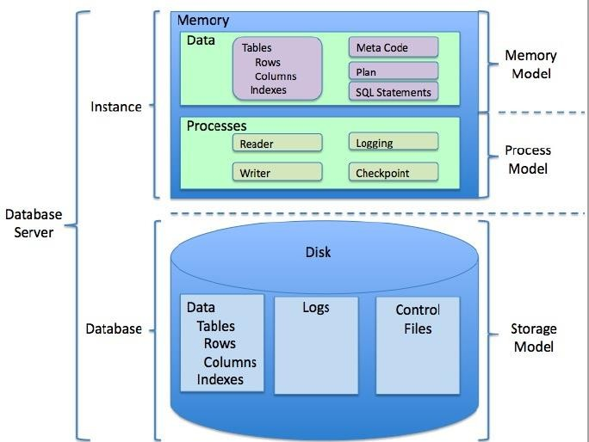

# FLOW DIAGRAMS:

**Flowchart:**

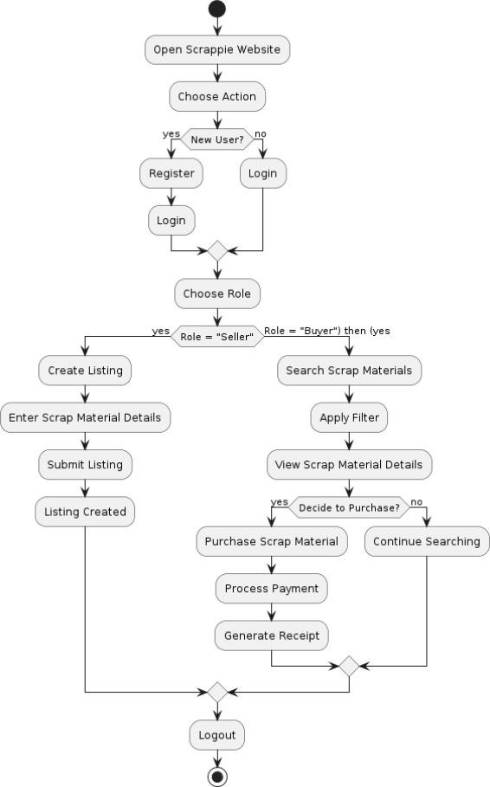

**Hierarchial Chart**

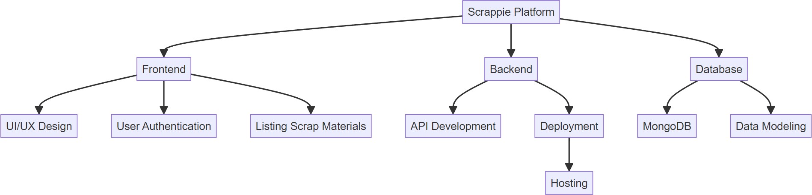

## Pie Chart

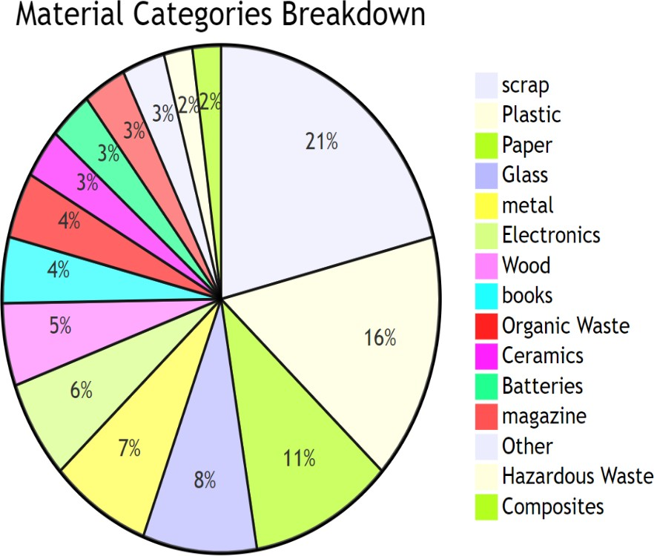

## SOFTWARE DESIGN

* + 1. **Use Case Diagram:**

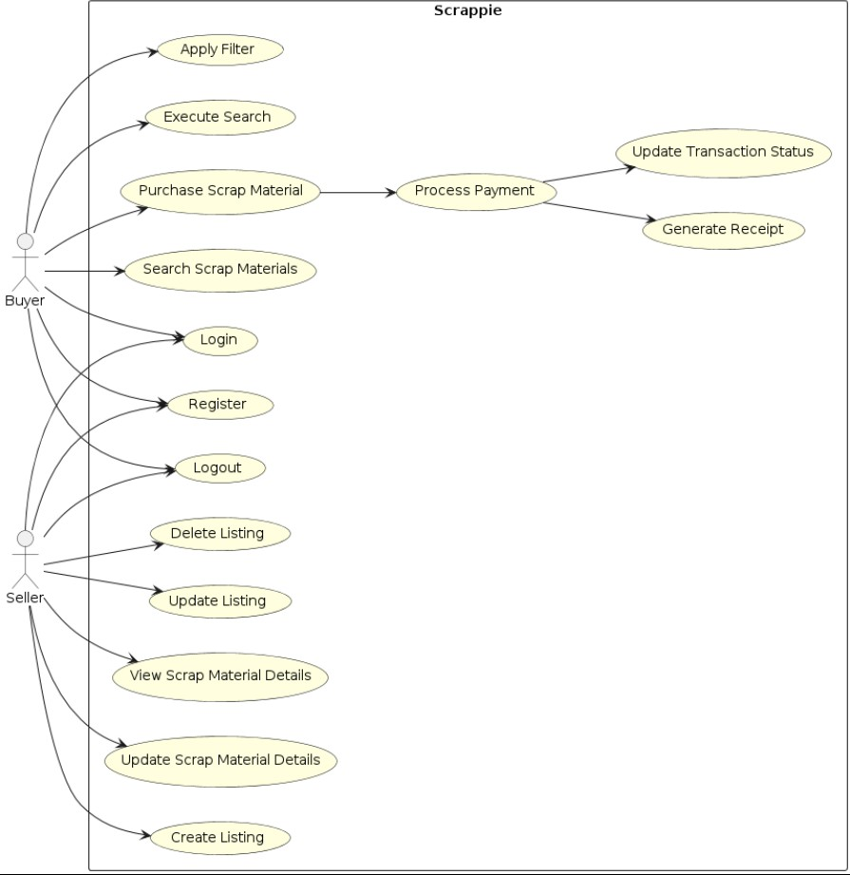

# Sequence Diagram

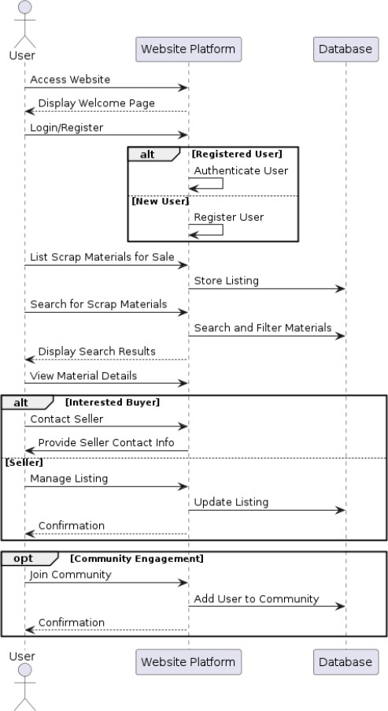

* + 1. **Collaboration Diagram**

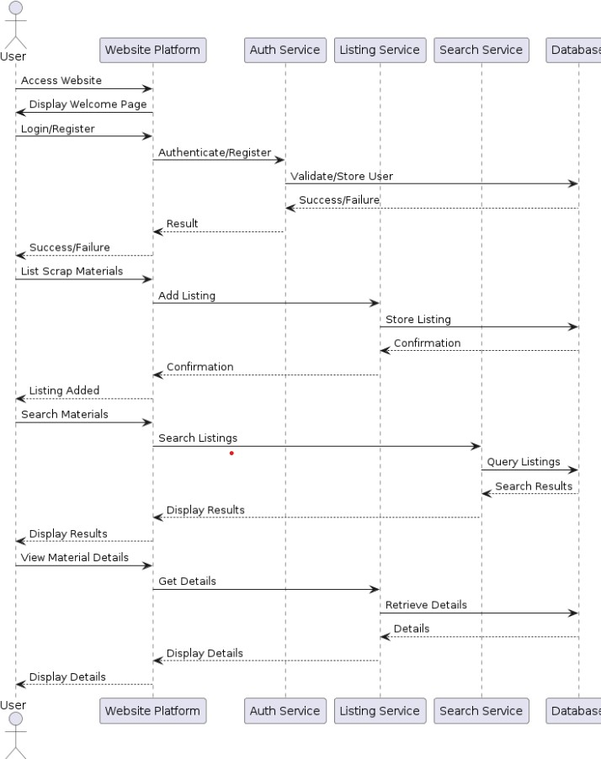

# Class Diagram

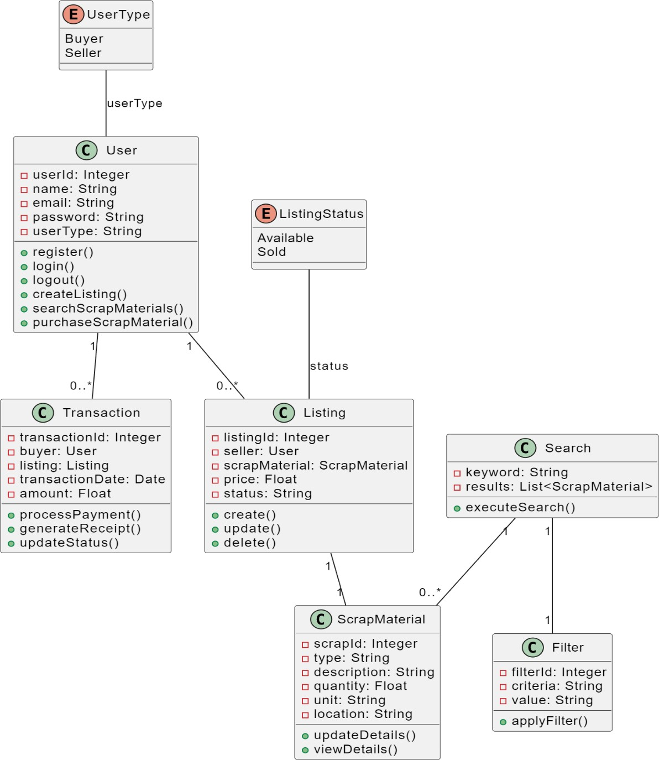

### Activity Diagram

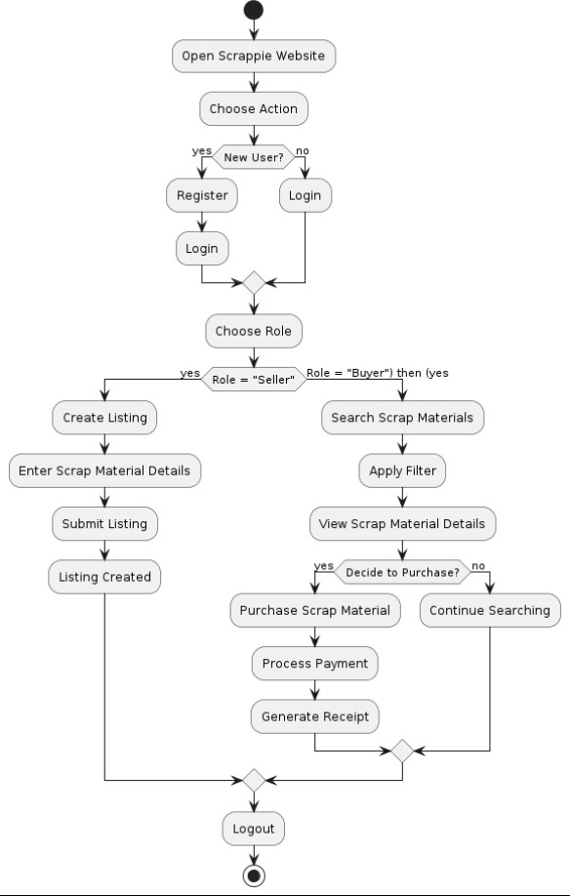

1. **Component Diagram:**

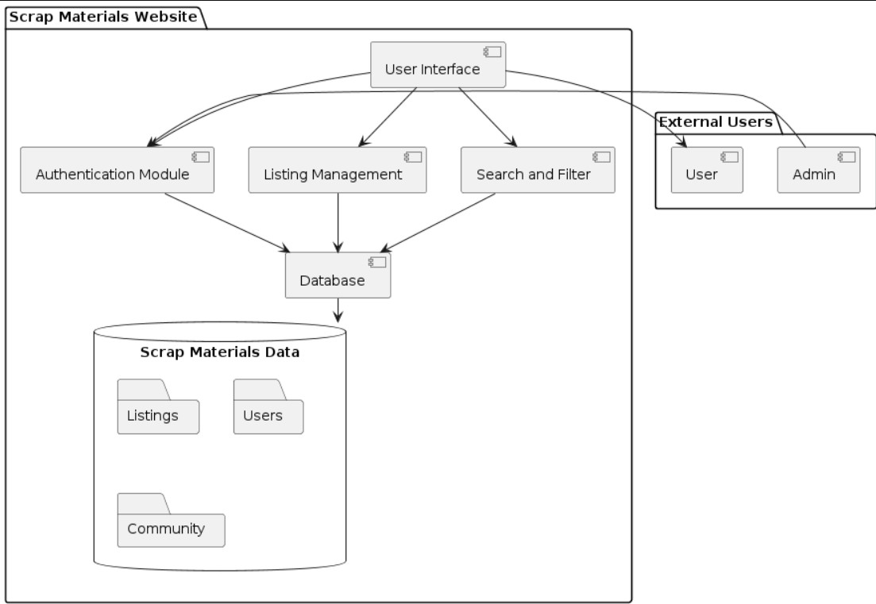

1. **Deployment**



# MODULE DESCRIPTION:

* 1. User Management Module
     + **Purpose:** Manages user accounts and profiles.

#### Features:

* + - * User registration and authentication.
      * Profile management (view, edit personal information).
      * Role-based access control (e.g., seller, buyer).
  1. Listing Management Module
     + **Purpose:** Facilitates the creation, viewing, and management of scrap material listings.

#### Features:

* + - * Create and edit listings with detailed descriptions, images, and pricing.
      * View all active listings.
      * Search and filter listings based on categories, location, price, and other criteria.
  1. Transaction Management Module
     + **Purpose:** Handles the buying and selling transactions between users.

#### Features:

* + - * Process transactions securely through integrated payment gateways.
      * Track transaction status (e.g., pending, completed, canceled).
      * Generate transaction history for users.
  1. Review and Rating Module
     + **Purpose:** Allows users to provide feedback on listings and transactions.

#### Features:

* + - * Submit reviews and ratings for materials and transactions.
      * View ratings and reviews to assess the credibility and quality of materials.
  1. Category Management Module
     + **Purpose:** Manages the categorization of scrap materials for better organization and searchability.

#### Features:

* + - * Create, edit, and delete categories.
      * Assign listings to relevant categories.
  1. Address Management Module
     + **Purpose:** Handles user address information for listings and transactions.

#### Features:

* + - * Store and manage multiple addresses for users.
      * Associate listings with specific addresses for accurate location data.

# IMPLEMENTATION:

<!DOCTYPE html>

<html lang="en">

<head>

    <meta charset="UTF-8">

    <meta name="viewport" content="width=device-width, initial-scale=1.0">

    <title>Scrap Form</title>

    <link rel="stylesheet" href="https://stackpath.bootstrapcdn.com/bootstrap/4.5.2/css/bootstrap.min.css">

    <style>

        body {

        background-color: #f8f9fa;

        background-image: url('./image.png');

        background-size: cover;

        background-position: center;

    }

        .form-container {

            background-color: #ffffff;

            padding: 30px;

            border-radius: 5px;

            box-shadow: 0 0 10px rgba(0, 0, 0, 0.1);

            margin: 20px auto;

            max-width: 700px;

        }

        .form-title {

            text-align: center;

            margin-bottom: 20px;

        }

        .footer {

            text-align: center;

            margin-top: 20px;

        }

    </style>

</head>

<body>

    <nav class="navbar navbar-expand-lg navbar-light bg-light">

        <a class="navbar-brand" href="#">SCRAPPIE</a>

        <button class="navbar-toggler" type="button" data-toggle="collapse" data-target="#navbarNav" aria-controls="navbarNav" aria-expanded="false" aria-label="Toggle navigation">

            <span class="navbar-toggler-icon"></span>

        </button>

<div class="collapse navbar-collapse" id="navbarNav">

            <ul class="navbar-nav ml-auto">

                <li class="nav-item">

                    <a class="nav-link" href="#">Home</a>

                </li>

<li class="nav-item">

    <a class="nav-link" href="#">About</a>

</li>

<li class="nav-item">

    <a class="nav-link" href="#">Scrap Rates</a>

</li>

</ul>

</div>

</nav>

<div class="container">

<div class="form-container">

<h2 class="form-title">Scrap Form</h2>

<form>

<div class="form-group">

    <label for="firstName">First Name</label>

    <input type="text" class="form-control" id="firstName" placeholder="First Name" required>

</div>

<div class="form-group">

    <label for="phoneNumber">Phone Number</label>

    <div class="input-group">

        <div class="input-group-prepend">

            <span class="input-group-text">+91</span>

        </div>

        <input type="tel" class="form-control" id="phoneNumber" placeholder="Phone Number" required>

    </div>

</div>

<div class="form-group">

    <label for="streetAddress">Street Address</label>

    <input type="text" class="form-control" id="streetAddress" placeholder="E.g. 42 Wallaby Way" required>

</div>

<div class="form-group">

    <label for="apartment">Apartment, suite, etc.</label>

    <input type="text" class="form-control" id="apartment" placeholder="Apartment, suite, etc.">

</div>

    <div class="form-group col-md-6">

        <label for="city">City</label>

        <input type="text" class="form-control" id="city" placeholder="E.g. Sydney" required>

    </div>

    <div class="form-group col-md-6">

        <label for="state">State/Province</label>

        <input type="text" class="form-control" id="state" placeholder="E.g. New South Wales" required>

    </div>

</div>

<div class="form-group">

    <label for="zip">ZIP / Postal Code</label>

    <input type="text" class="form-control" id="zip" placeholder="E.g. 2000" required>

</div>

<div class="form-group">

    <label for="date">Date</label>

    <input type="date" class="form-control" id="date" required>

</div>

# TTESTCASES:

<div class="form-group">

    <label>Checkbox</label>

    <div class="form-check">

        <input class="form-check-input" type="checkbox" id="newspaper">

        <label class="form-check-label" for="newspaper">Newspaper</label>

    </div>

    <div class="form-check">

        <input class="form-check-input" type="checkbox" id="books">

        <label class="form-check-label" for="books">Books</label>

    </div>

    <div class="form-check">

        <input class="form-check-input" type="checkbox" id="plastic">

        <label class="form-check-label" for="plastic">Plastic</label>

    </div>

    <div class="form-check">

        <input class="form-check-input" type="checkbox" id="iron">

        <label class="form-check-label" for="iron">Iron</label>

    </div>

    <div class="form-check">

        <input class="form-check-input" type="checkbox" id="brass">

        <label class="form-check-label" for="brass">Brass</label>

    </div>

    <div class="form-check">

        <input class="form-check-input" type="checkbox" id="tyre">

        <label class="form-check-label" for="tyre">Tyre</label>

    </div>

</div>

<div class="form-group">

    <label for="fileUpload">Upload file</label>

    <input type="file" class="form-control-file" id="fileUpload">

</div>

<button type="submit" class="btn btn-primary btn-block">Send Message</button>

</form>

</div>

</div>

<script src="https://code.jquery.com/jquery-3.5.1.slim.min.js"></script>

<script src="https://cdn.jsdelivr.net/npm/@popperjs/core@2.5.3/dist/umd/popper.min.js"></script>

<script src="https://stackpath.bootstrapcdn.com/bootstrap/4.5.2/js/bootstrap.min.js"></script>

</body>

</html>

#### Test Case: Create New Listing

* + **Description:** Verify that a user can create a new scrap material listing.

#### Steps:

1. Navigate to the create listing page.
2. Fill in the listing details (e.g., name, description, price).
3. Upload images.
4. Submit the form.
   * **Expected Result:** Listing is created and displayed in the listings page.

#### Test Case: display Listings

* + **Description:** Verify that users can search for listings.

#### Steps:

1. Navigate to the listing page.
2. Look for the criteria (e.g., material name, category).
3. Click on sell now button.
   * **Expected Result:** By clicking sell now button navigates to scrap form page.

3

# OUTPUT SCREENS:

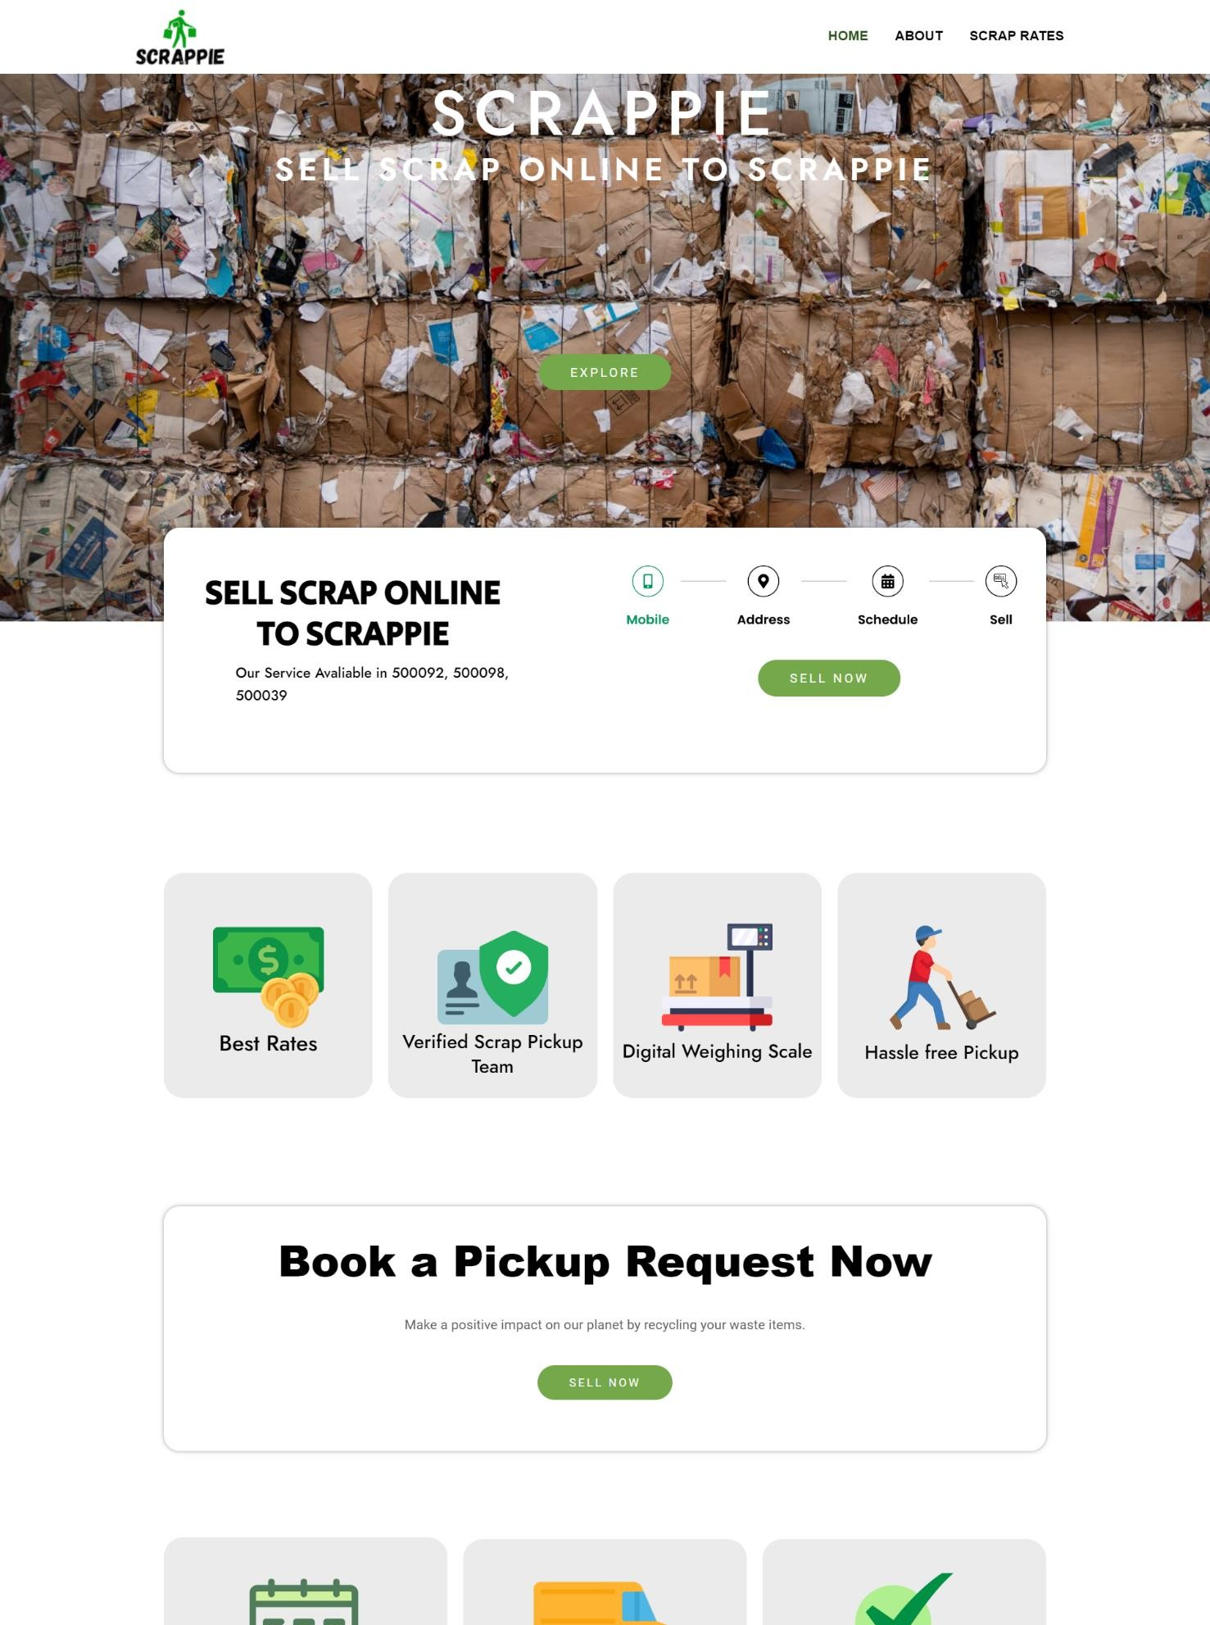**Home Page:**

# ABOUT PAGE:

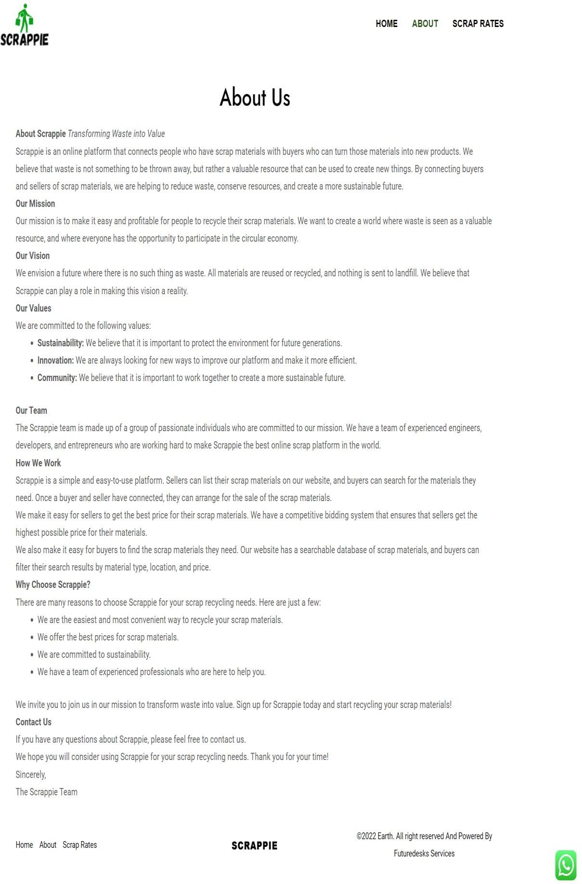

**SCRAP RATES PAGE:**

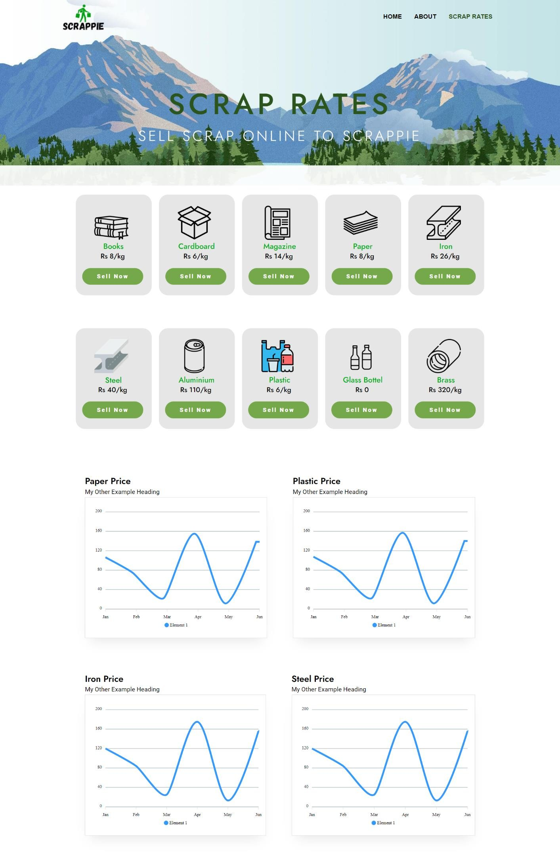

# SCRAP FORM PAGE:

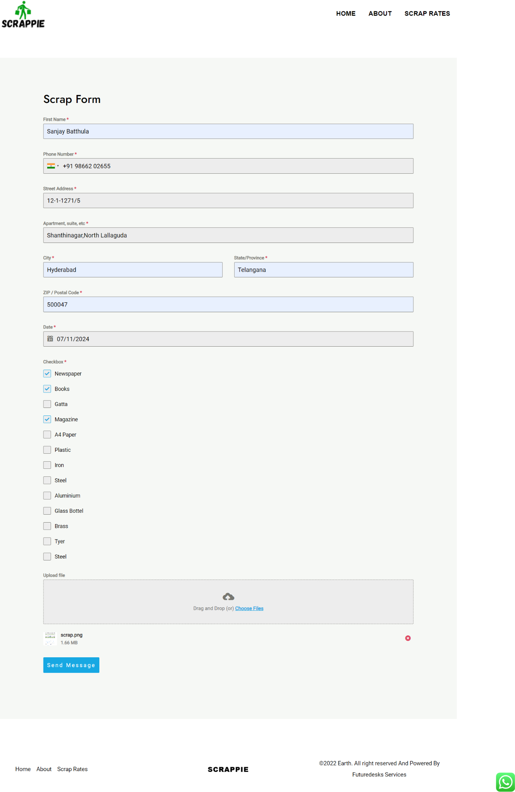

1. **CONCLUSION:**

In summary, Scrappie offers a comprehensive solution to address waste management challenges while promoting environmental sustainability and social responsibility. The Platform enhances accessibility and convenience for users, fostering community engagement and transparency in waste management practices. Through its wide range of accepted materials and donation options for charitable causes, the system encourages resource conservation, pollution prevention, and economic growth and create a cleaner, healthier environment for current and future generations.

# FUTURE ENHANCEMENTS:

The Scrappie platform aims to continuously evolve and adapt to meet user needs and market demands. Here are some future enhancements planned for the platform:

* 1. *Mobile Application*
     + **Objective:** Increase accessibility and convenience for users.

#### Features:

* + - * Develop native mobile applications for iOS and Android.
      * Provide push notifications for real-time updates.
      * Enable users to list and search for scrap materials on-the-go.
  1. *Advanced Analytics and Reporting*
     + **Objective:** Provide deeper insights for users and administrators.

#### Features:

* + - * Implement advanced data analytics to track market trends.
      * Offer detailed reporting tools for sellers to analyze their sales performance.
      * Provide administrators with dashboards to monitor platform health and user activity.
  1. *AI-Powered Recommendations*
     + **Objective:** Improve user experience with personalized suggestions.

#### Features:

* + - * Develop machine learning algorithms to recommend materials based on user behavior.
      * Implement AI-driven search enhancements to provide more relevant results.
      * Offer personalized notifications for new listings and price drops.

# REFERENCES

#### Books and Journals:

*Books*

1. Pichtel, J. (2014). *Waste management practices: Municipal, hazardous, and industrial*. CRC Press.
2. Thompson, R. (2013). *Sustainable materials, processes and production*. Thames & Hudson.

*Journals*

1. Smith, A., Brown, K., Ogilvie, S., et al. (2020). The role of waste management in reducing greenhouse gas emissions: A review. *Journal of Environmental Management*, 265, Article 110512. https://doi.org/10.1016/j.jenvman.2020.110512
2. Jones, D., Harrison, P., Martin, J. (2021). Innovative approaches in waste management and recycling. *Waste Management & Research*, 39(5), 487-498. https://doi.org/10.1177/0734242X21992345

#### Articles and Papers:

*Articles*

1. Smith, A., Brown, K., Ogilvie, S., et al. (2020). The role of waste management in reducing greenhouse gas emissions: A review. *Journal of Environmental Management, 265*, Article 110512. https://doi.org/10.1016/j.jenvman.2020.110512
2. Jones, D., Harrison, P., Martin, J. (2021). Innovative approaches in waste management and recycling. *Waste Management & Research, 39*(5), 487-498. https://doi.org/10.1177/0734242X21992345

*Papers*

5. Thompson, R., Parker, D., Johnson, L. (2021). Assessing the environmental impact of waste management systems. *Environmental Science & Technology, 55*(6), 3627-3639. https://doi.org/10.1021/acs.est.0c06559

**Web Resources:**

1. World Wide Web Consortium. (2024). HTML Living Standard. Retrieved July 11, 2024, from https://html.spec.whatwg.org/multipage/
2. MongoDB. (n.d.). MongoDB Documentation. Retrieved July 11, 2024, from <https://docs.mongodb.com/>

### Case Studies and Reports:

* + Johnson, M., & Smith, L. (2020). Sustainable waste management practices: A case study of urban recycling initiatives. *Environmental Case Studies*, 15(2), 45-56. https://doi.org/10.1080/14719037.2020.1754321
  + United Nations Environment Programme. (2019). *Global waste management outlook*. Retrieved from https://[www.unenvironment.org/resources/report/global-waste-](http://www.unenvironment.org/resources/report/global-waste-) management-outlook-2019